**PRACTICAL – 14**

**AIM:**

Create an I-OS Application to Change the Image Displayed on the Screen.

**DESIGN:**

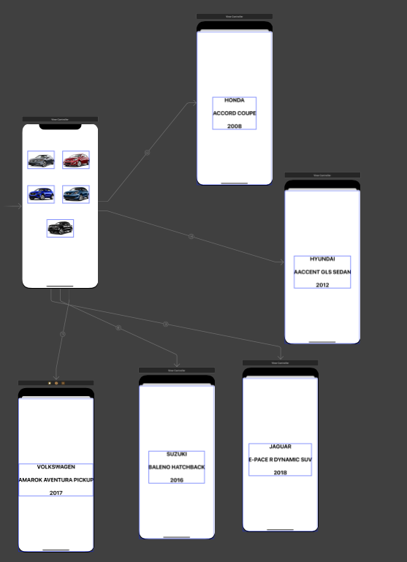

**IMAGE ASSETS:**

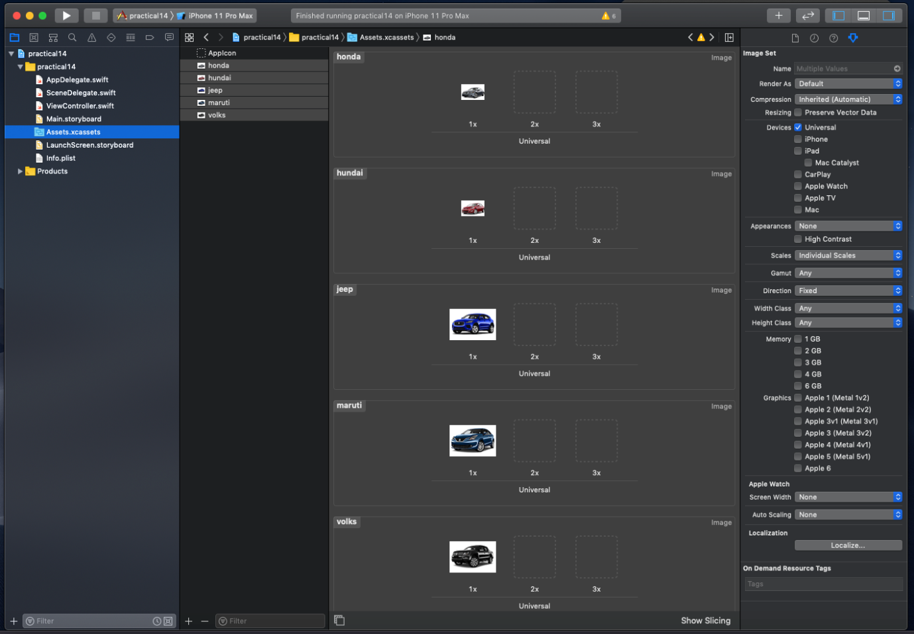

**PROGRAM CODE:**

import UIKit

class ViewController: UIViewController {

override func viewDidLoad() {

super.viewDidLoad()

// Do any additional setup after loading the view.

}

}

**OUTPUT:**

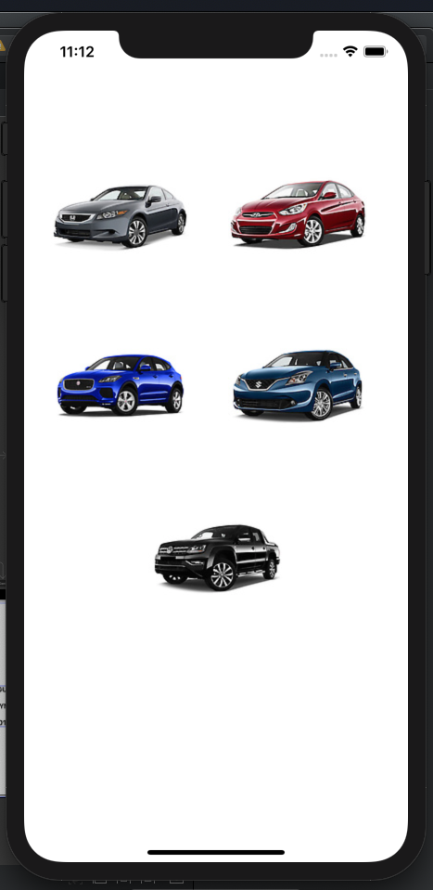

**ON CLICK OF FIRST CAR:**

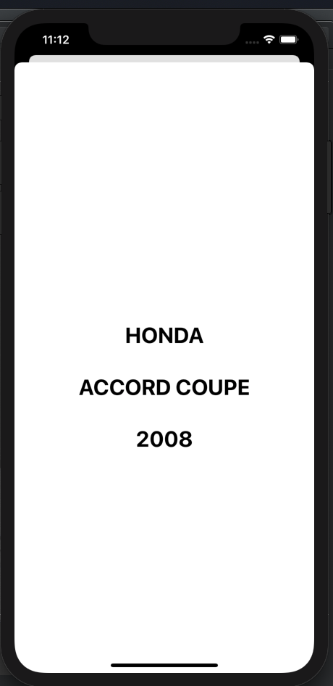

**ON CLICK OF SECOND CAR:**

